**1. Introduction:**

Nike is an American multinational organization that's locked in within the plan, advancement, fabricating, and around the world promoting and deals of footwear, attire, gear, extras, and administrations. The company is headquartered close Beaverton, Oregon, within the Portland metropolitan region. It is the world's biggest provider of athletic shoes and apparel and a major producer of sports gear, with income in abundance of US$37.4 billion in its financial year 2020. As of 2020, it utilized 76,700 individuals around the world.

In 2020 the brand alone was esteemed in overabundance of $32 billion, making it the foremost profitable brand among sports businesses. Previously in 2017, the Nike brand was esteemed at $29.6 billion. Nike ranked No. 89 within the 2018 Fortune 500 list of the biggest Joined together States organizations by add up to revenue’s 2018’s monetary articulation of Nike, appears that 90% of Nike’s deals are cantered on Offering shoes and 10% as it were on sportswear and other embellishments.

We planned a study to discover out our customers’ conclusions almost nike brand and nike inclinations. As well as the presentation, this report will contain the taking after areas:

• **Methodology for Issue Determination** – portraying how the investigate was carried out

• **Results and Arrangements: Portion 1** – giving subtle elements around data found by the investigate and suggestions based on the information analysis

• **Results and Arrangements: Portion** 2 – giving assist points of interest almost data found by the investigate and suggestions based on the information analysis

• **Conclusions** – a outline of suggestions as well as proposals on how to make strides current and future research

2. **Methodology for Problem Resolution:**

The survey (see Reference section A) utilized 10 questions – 8 x MCQ, 2 x scaled reaction. We inquired a few common questions around the respondents’ choices when buying nike items some time recently centering on the questions on nike items. The study was carried out between 26-29th Walk 2018 in Jimi Shopping center, Al Ain Shopping center and Bawadi Shopping center, all in Al .We met both guys and females, matured 20+ on 19-24th November at 8am to 12pm.We disperse the study online by WhatsApp and over as they are the individuals who are more likely to purchase nike for their families. Our test measure was 129 since there was not much time to carry out the overview. We anticipated that our study would appear that individuals did not know almost our nike items.

**3. Results and Solutions: Part 1:**

We focused on 4 charts from the survey:

Chart 1 (see Appendix B) asked if people choose pair of nike products so which pair of shoes people want to buy and also the overall performance of buying either pair of nike shoes . 82.5% approve of our products. Only 28.5% disagreed with the statement. This shows we have a lot of customer loyalty to build on.

• ***We highly recommend that nike brand continues with its production of shoes because we have a strong customer base that views nike products favourably.***

Chart 2 (see Appendix B) shows how comfortable our shoes are. So , in this regard people give rank to nike on the basis of their comfortability and that are given below . {people are extremely comfortable with Nike shoes}

* 37.50% extremely comfortable
* 52.50% very comfortable
* 15% somewhat comfortable
* 2.50% not so comfortable
* 2.50% not at all comfortable

• ***In this regard we suggested that most of the people like the nike brand because of their comfotability and because of their higher preferences . In future the selling rate of nike brand is increasing very swiftly.***

4. Results and Solutions: Part 2:

Chart 3 (see Appendix C) aimed at finding that Nike staff are helpful. Again, the loyalty of our customers was very strong with 52.50% of respondents that the staff go nike brand is very cooperative and respectful but only a few numbers 2.50% says that the staff of nike brand is not helpful.

• ***This indicates that our customers are in stores frequently, so we recommend offering a helpful staff that help the customers in buying nike best product according to their demands.***

The goal of the final chart (see Appendix C) was to find out the biggest Nike competitor? In this we want to find the those who are the biggest competitor of nike and that are given below.

* 92.5% Adidas
* 5% Vans
* 17.5% Sketchers
* 2.5% Reebok
* 0% Other

• ***We recommend that nike brand maintain its uniqueness, its good performance , its best and always make a quality products that customer always want to buy shoes only from nike brand and other brand are always being from nike brand.***

**5. Conclusions:**

We believe that we have met our aim of investigating possible solutions to increase sales of Al Ain Poultry.

**The following recommendations are based on the data from our survey:**

• release new items

• coupon for shoes

• continue with customers in a friendly way

• continue providing extremely comfortable shoes

• be the best and unique

**The following improvements would be needed to improve this research if it is repeated:**

• provide more size ranges

• focuses more in other categories like sportswear

**Suggestions for future research include:**

• sportswear sales? Soo much footwear

• 91.5% voters vote that adidas is the biggest Nike competitor

**Appendix A:**

Survey Instrument: Nike brand Questionnaire

1. How old are you?

|  |  |  |  |  |
| --- | --- | --- | --- | --- |
| 1. 20 | b. 21 | 1. 22 | d. 23 | e. other |

2. What is your gender

|  |  |
| --- | --- |
| a. male | b. female |

3. What is the favorite thing to get from nike

|  |  |  |  |  |
| --- | --- | --- | --- | --- |
| a. Shoes | b. Sports clothes | c. Sports accessories | d. Sports accessories | e. Other |

4. How comfortable nike shoes are?

|  |  |  |  |  |
| --- | --- | --- | --- | --- |
| a. extremely comfortable | b. very comfortable | c. somewhat comfortable | d. not so comfortable | e. not at all comfortable |

5. What word come in your mind when you think about nike?

|  |  |  |  |  |
| --- | --- | --- | --- | --- |
| a. strongly agree | b. agrees | c. neither agree nor disagree | d. disagrees | e. strongly disagree |

6. Every time I visit nike shop, staffs are helpful?

|  |  |  |  |  |
| --- | --- | --- | --- | --- |
| a. Adidas | b. Vans | c. Sketchers | d. Reebok | e. Other |

7. Which one is biggest nike competitor?

|  |  |  |  |  |
| --- | --- | --- | --- | --- |
| a. Adidas | b. Vans | c. Sketchers | d. Reebok | e. Puma |

8. What Is your favorite sport brand?

9. What are the reasons that you purchase nike?

|  |  |  |  |  |
| --- | --- | --- | --- | --- |
| a. better price that something I used | b. better quality that something I used | c. it serves my need that currently not being met | d. it makes a good gift | e. I purchase similar in past but need to relace |

10. If you buy pair of nike shoes that what is your choice?

|  |  |  |  |  |
| --- | --- | --- | --- | --- |
| 1. Nike air force 107 | 1. Nike zoom double stacked | 1. Nike air max 207 | d. Air Jordan 1aw | e. another |

**Appendix B:**

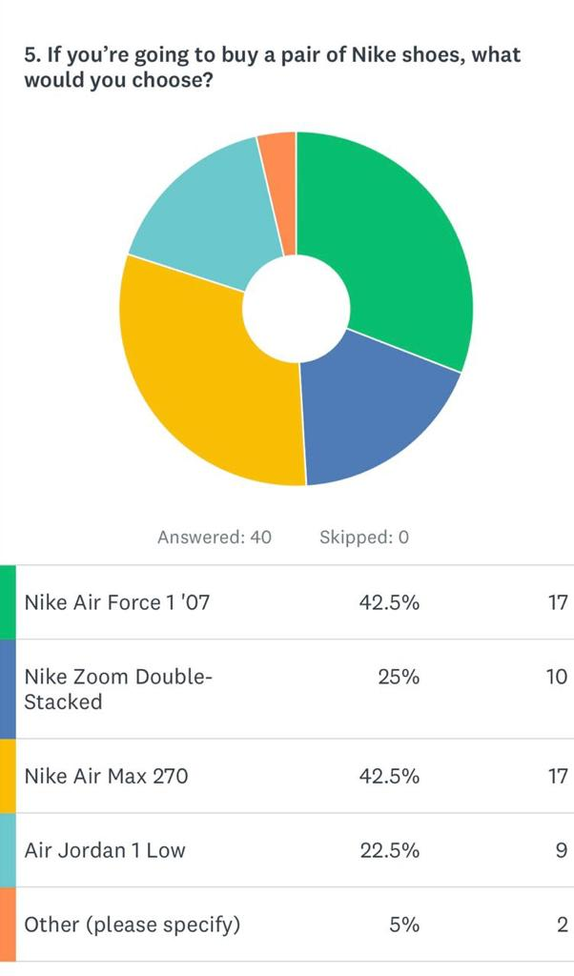

**Meaning:** This shows that what pair of shoes people choose?

**Recommendation:** Whatever they like they can purchase.

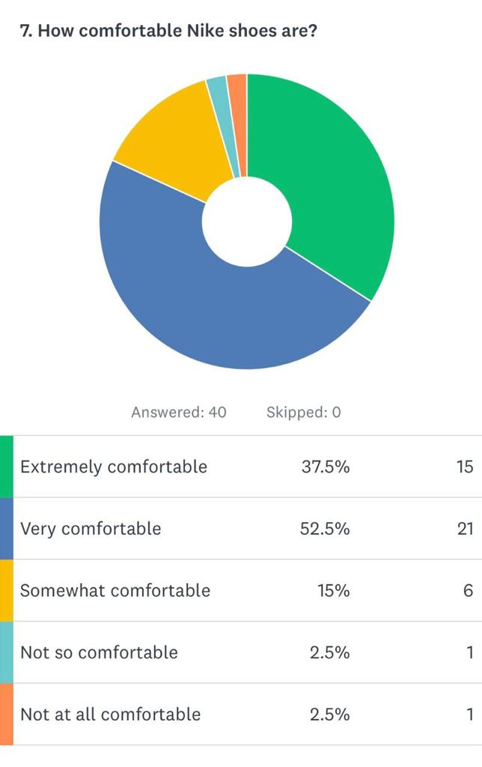

**Meaning:** This shows that people give ranking the comfortability of nike shoes?

**Recommendation:** People give ranking according to their experience.

**Appendix C:**

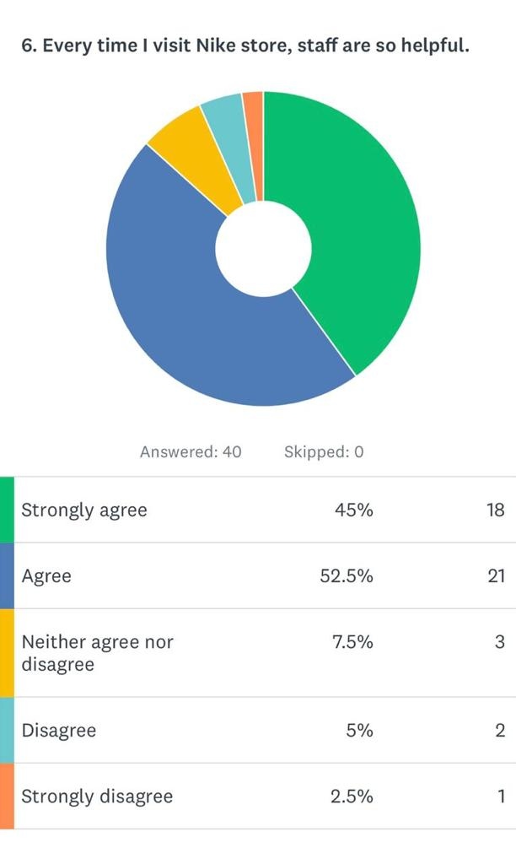

**Meaning:** Shows the staff of the nike are helpful?

**Recommendation:** Some are helpful and some not so all make helpful.

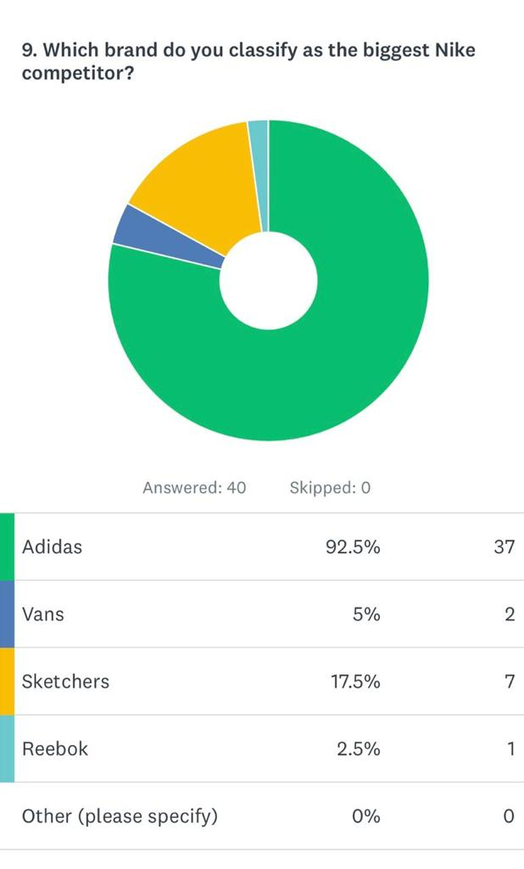

**Meaning:** Which one is the competitor of nike?

**Recommendation:** This ranking shows the nike competitor.